Handout Reference

1 Introduction
The stress-strain behavior of typical rubber materials is elastic but highly nonlinear.
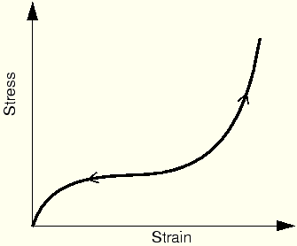
This type of material behavior is called hyperelasticity. The deformation of hyperelastic materials, such as rubber, remains elastic up to large strain values (often well over 100%).

2 Strain energy potential
ABAQUS uses a strain energy potential (U), rather than Young's modulus and Poisson's ratio, to relate stresses to strains in hyperelastic materials. Several different strain energy potentials are available: a polynomial model, the Ogden model, the Arruda-Boyce model, the Marlow model, and the van der Waals model. Simpler forms of the polynomial model are also available, including the Mooney-Rivlin, neo-Hookean, reduced polynomial, and Yeoh models.
The polynomial form of the strain energy potential is one that is commonly used. Its form is
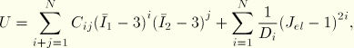
where U is the strain energy potential; is the elastic volume ratio; and are measures of the distortion in the material; and N, , and are material parameters, which may be functions of temperature. The parameters describe the shear behavior of the material, and the parameters introduce compressibility. If the material is fully incompressible (a condition not allowed in ABAQUS/Explicit), all the values of are set to zero and the second part of the equation shown above can be ignored. If the number of terms, N, is one, the initial shear modulus, , and bulk modulus, , are given by
and
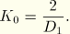
If the material is also incompressible, the equation for the strain energy density is
This expression is commonly referred to as the Mooney-Rivlin material model. If is also zero, the material is called neo-Hookean.

You must provide ABAQUS with the relevant material parameters to use a hyperelastic material. For the polynomial form these are and . It is possible that you will be supplied with these parameters when modeling hyperelastic materials; however, more likely you will be given test data for the materials that you must model. Fortunately, ABAQUS can accept test data directly and calculate the material parameters for you (using a least squares fit).

